Curriculum vitae apl. Prof. Dr. Klemens Horst, MHBA
Surname / First name  Date of birth  Academic degrees  Present position and title  Institute / Department  University / Institution  Office address  e-mail | 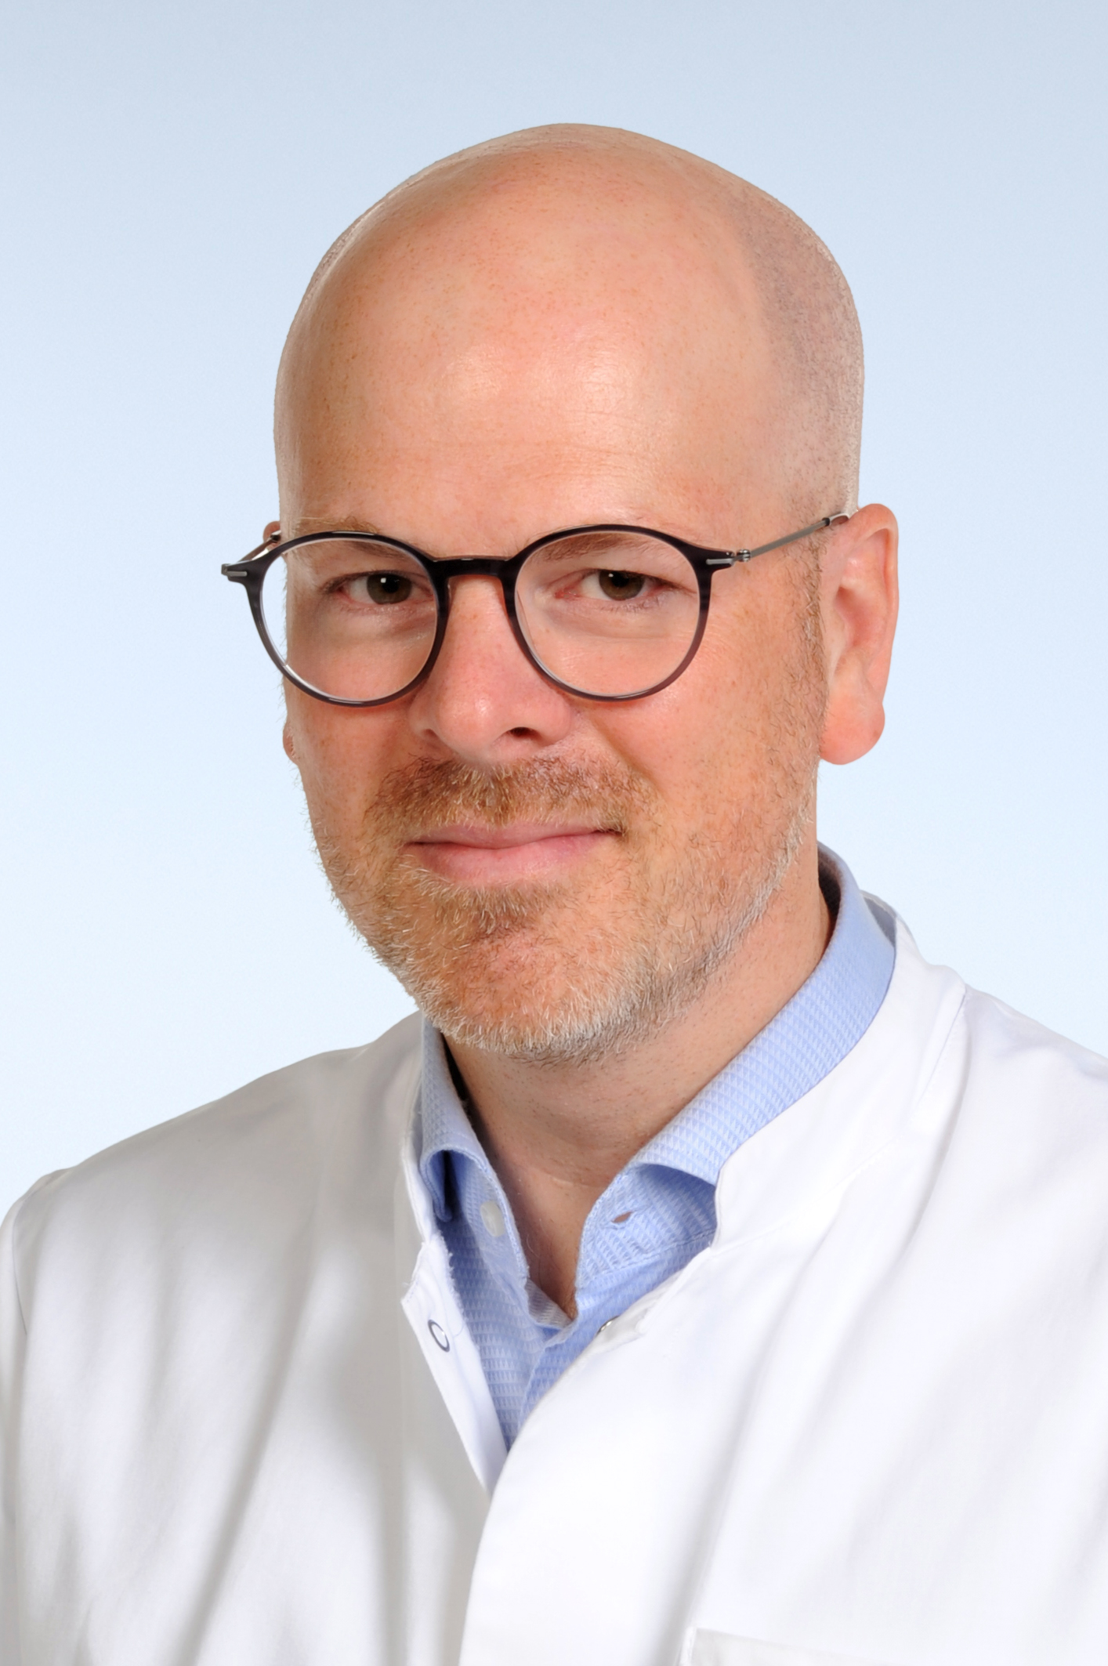  Horst / Klemens  27.09.1982  apl. Prof. Dr. med., MHBA  Head Attending, Associate Professor  Department for Orthopedics, Trauma and Reconstructive Surgery  University Hospital Aachen  Pauwelsstrasse 30, 52074 Aachen, Germany  khorst@ukaachen.de

Education / Training

Institution and location | Degree | Year
University Witten/Herdekce | MD | 2010
University Nürnberg/Erlangen | MHBA | 2015
Department of Orthopedic Trauma and Reconstructive Surgery, University Hospital Aachen, Germany | Assistant Professor | 2018
Department of Orthopedic Trauma and Reconstructive Surgery, University Hospital Aachen, Germany | Associate Professor | 2023

Position and employment
Year (date) | Position | Institution and location
2010 | Resident | Department of Trauma and Reconstructive Surgery at Aachen University Hospital
2017 | Board Certification | “Notfallmedizin”
2017 | Board Certification | “Orthopädie und Unfallchirurgie”
2017 | Board Certification | “Trauma Surgery” by European Board of Surgery (EBS)
2017 | Consultant | Department of Trauma and Reconstructive Surgery at Aachen University Hospital
2019 | Board Certification | “Spezielle Unfallchirurgie”
2019 | Senior Consultant | Department of Orthopedic Trauma and Reconstructive Surgery, University Hospital Aachen, Germany
2021 | Board Certification | “Sportmedizin”
2021 | Board Certification | “Physikalische Therapie”
2022 | Board Certification | “Manuelle Therapie”
2022 | Head Attending | Department of Orthopedic Trauma and Reconstructive Surgery, University Hospital Aachen, Germany
2024 | Board Certification | “Spezielle Orthopädische Chirurgie”

Other experience and professional membership
Year (date) | Position | Institution and location
Since 2011 | Member | German Trauma Society (DGU)
Since 2011 | Member | German Society for Orthopaedics and Trauma (DGOU)
Since 2012  Since 2022 | Member | German Society for Shoulder- and Elbow Surgery (DVSE)  Expert-Certificate
Since 2014  Since 2022 | Member  Member | AO Trauma  AO Academy
Since 2014  Since 2023 | Member  Chair | European Society for Trauma & Emergency Surgery (ESTES)  Section Polytrauma
Since 2018  2019-2023 | Member  Board member | Section Surgical Research (German Surgical Society)
Since 2022 | Member | German Society for Endoprosthetics
Since 2022 | Board Member | German Trauma Society (Nichtständiger Beirat)
Since 2022 | Member | Section „Notfall-, Intensivmedizin & Schwerverletztenversorgung (NIS)“
2022 | Certificate | Didactics in Medicine by Landesakademie für Medizinische Aus- und Weiterbildung (LAMA)
Since 2023 | Member | Excellence-Academy by the Convent of Ordinaries in Orthopaedics and Traumatology Germany
2023 | Certificate | “Hip Surgeon” by German Hip Society
2024 | Certificate | “Spine Surgeon (Basis)” by German Spine Society

Honors
Year (date) | Description
2008 | Grant by Colind Pond Foundation
2012 | Grant by Alwin Jäger Foundation
2013-2015 | RWTH grant for young scientists
2014 | New Investigator Travel Award (Shock Society, USA)
2014 | Fellowship by German Society for Shoulder- and Elbow Surgery
2015 | Congress Grant by ESTES
2015 | Best Oral Presentation Award (3rd Prize) auf dem European Congress of Trauma and Emergency Surgery, Amsterdam/Niederlande
2016 | Travel Award der Orthopaedic Research Society (San Diego/USA)
2017 | Innovation Prize by German Trauma Society (DGU)
2018 | TraumaRegister DGU-Publikation des Jahres (Co-Autor)
2021 | Science Prize by AO Trauma Germany
2022 | Membership of the AO Academy Germany
2022 | Hans-Liniger Prize by the German Trauma Society (DGU)
2023 | Membership of the Excellence-Academy by the Convent of Ordinaries in Orthopaedics and Traumatology Germany
2024 | Rebischke-Stipendium der Stiftung Endoprothetik

